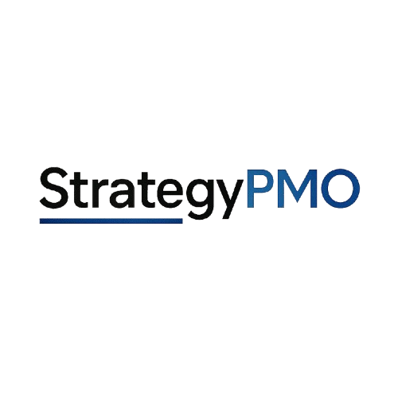
CAPABILITY STATEMENT
Enterprise Portfolio Governance, PMO Reset, and Transformation Stabilization
Overview  StrategyPMO is an executive advisory and consulting practice focused on restoring execution discipline in complex enterprise environments. The firm works with leadership teams when important work has become difficult to control, governance is no longer creating enough clarity, and transformation efforts are losing momentum across fragmented teams and priorities.  Core Capabilities  Portfolio Stabilization – Restore control across overloaded or unclear portfolios, improve visibility into execution risk, and reestablish prioritization discipline.  PMO and Governance Reset – Redesign governance structures, reporting cadence, escalation paths, and accountability models to support executive decision-making.  Transformation Stabilization and Recovery – Stabilize high-risk initiatives by improving coordination, strengthening execution discipline, and restoring alignment across workstreams.  Executive Decision Support – Improve decision clarity through structured reporting, prioritization frameworks, and governance operating models.  Differentiators  Executive-Level Focus – Engagements are designed to support senior leadership decision-making, not administrative project tracking.  Intervention-Oriented Approach – Focused on restoring control and stabilizing execution in high-risk environments, not maintaining status quo operations.  Cross-Industry Experience – Experience across enterprise technology, fintech, healthcare, insurance, and public sector environments.  Governance as a Control System – Positions governance as a mechanism for enforcing tradeoffs, improving alignment, and sustaining execution reliability.  Representative Experience  Portfolio governance for enterprise fintech environments supporting global product and operational initiatives.  Transformation stabilization in cross-functional enterprise programs with fragmented ownership and delivery risk.  PMO design and governance implementation in organizations requiring improved execution discipline and visibility.  Merger and integration readiness support across complex, multi-workstream environments.  Cloud transformation governance aligning infrastructure, security, and development teams under unified execution control.  Clients and Environments  Experience includes Fortune 100 and Fortune 500 organizations, regulated industries, enterprise technology environments, financial services, healthcare, and public sector programs. | Code Information  EIN: 39-2278568  DUNS: 139069193  Business Info  Business Type:  Single-Member LLC  MBE Certified  NAICS Codes:  541611  541618  611430  Contact Information  Address:  StrategyPMO  5900 Balcones Drive  Suite 100  Austin, TX 78731  Email: info@strategypmo.com  Phone:  737-206-6544  Web:  www.StrategyPMO.com

